[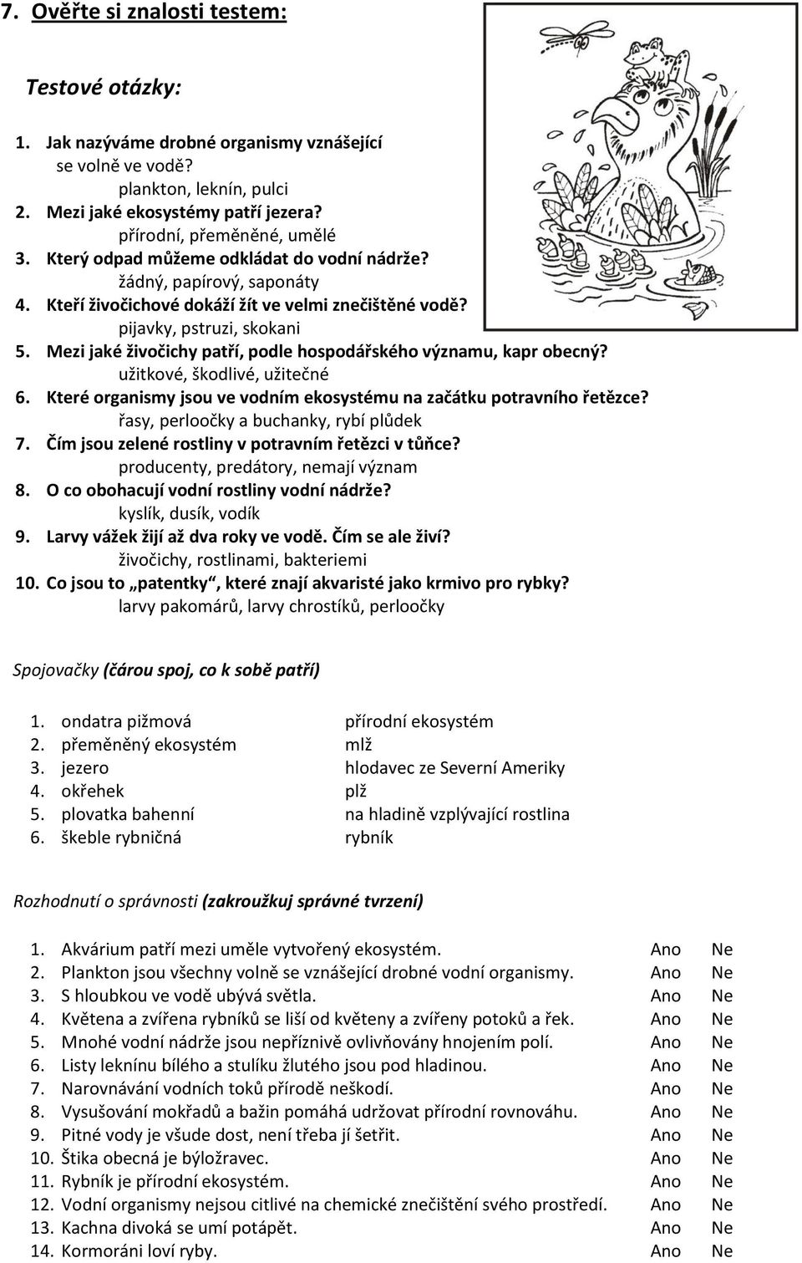](https://www.google.cz/url?sa=i&url=https://docplayer.cz/4736967-7-ekosystem-rybnika.html&psig=AOvVaw29XmYR_vMLTXvWcWFcEB4w&ust=1584975434752000&source=images&cd=vfe&ved=0CAIQjRxqFwoTCLjm6eCrrugCFQAAAAAdAAAAABAd)